**Entity Framework In Asp.Net Mvc**

**APPLICATION**

**OBJECT**

**OBJECT**

* Ado.Net
* SqlConnection
* SqlCommand
* SqlDataReader
* SqlDataAdapter
* Stored Procedures
* Manual Mapping

**FRAMEWORK**

**DATABASE**

To address the data access requirements of ASP.NET MVC application, you can use an ORM (OBJECT RELATIONAL MAPPING) framework.

**An ORM framework:**

* Simplifies the process of accessing data from applications.
* ORM is a tool for storing data from domain objects to relational database.

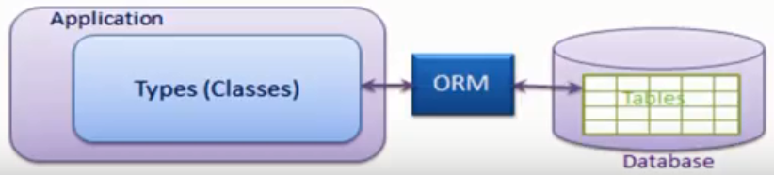

**Entity Framework:**

* The Entity Framework is an ORM framework that ASP.NET MVC applications can use.
* The Entity Framework is an implementation of the Entity Data Model (EDM), which is a conceptual model that describes the entities and the associations they participate in an application.
* The Entity Data Model (EDM) is a set of concepts that describe the structure of data.
* Entity Data Model is a model that describes entities and the relationships between them.
* EDM allows you to handle data access logic by programming against entities without having to worry about the structure of the underlying data store and how to connect with it.
* Entity Framework eliminates the need to write most of the data-access code that otherwise need to be written.
* It is an enhancement to ADO.NET that gives developers an automated mechanism for accessing and storing the data in the database.
* Using the Entity Framework, developers issue queries using LINQ (Language integrated query), then retrieve and manipulate data as strongly type objects.

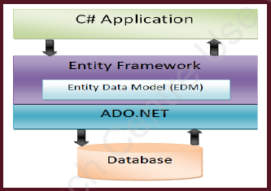

* Uses different approaches to manage data related to an application.
  + CODE FIRST APPROACH
  + DATABASE FIRST APPROACH
  + MODEL FIRST APPROACH

**Code-First Approach Of Entity Framework In ASP.Net MVC**

In the code-first approach the Entity Framework creates database objects based on model classes that you create to represent application data.

**Database-First Approach Of Entity Framework In ASP.Net MVC**

In the database-first approach the Entity Framework creates model classes and properties corresponding to the existing database objects, such as tables and columns.

**Model First Approach Of Entity Framework In ASP.Net MVC**

In Model First, you define your model in an Entity Framework designer then generate SQL, which will create database schema to match your model and then you execute the SQL to create the schema in your database.